THE FORGOTTEN PEOPLE: NEW POEM AND FILM RELEASED BY LADY UNCHAINED

- New poem highlights racial inequality in the UK prison system
- Written by poet, storyteller and advocate for life after prison Lady Unchained in response the Black Lives Matter protests in summer 2020
- Filmed in locations across London by award-winning cinematographer Tracy Kiryango
- Film of the poem released online on 18 January
- Hear how the film was made in an online Q&A with Lady Unchained and cinematographer Tracy Kiryango on 28 January.

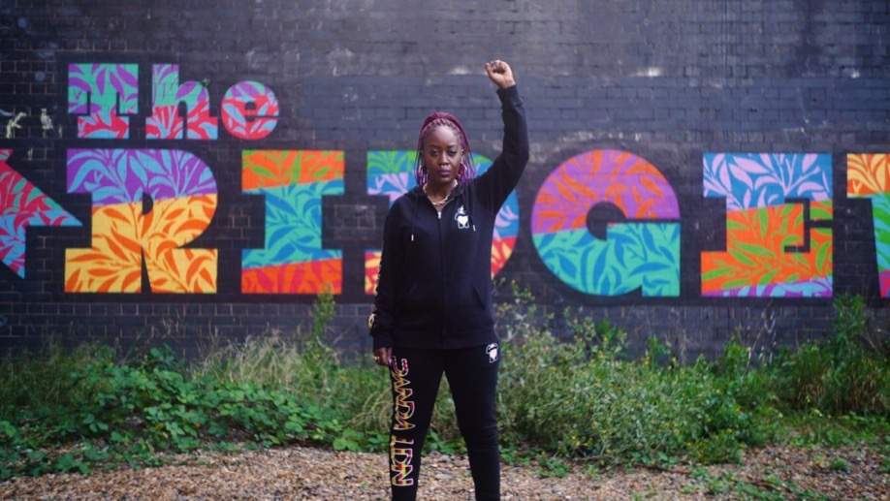
Film still, Lady Unchained in the Forgotten People

On 18 January 2021, The Forgotten People, a new poem and film written and performed by artist and poet Lady Unchained, will be released online and hosted on Artsadmin’s website until 18 February. Commissioned by Artsadmin in summer 2020, The Forgotten People highlights racial inequality in the UK prison system and was written in response the Black Lives Matter protests in summer 2020.
“This poem is my personal campaign against the criminal justice system. We need to change the sentencing process and the way Black people are treated within the system from searches, to arrests, to court, to prison. After serving time in prison myself, I found out that being Black was a crime in the UK. There are so many Black women and men serving sentences for crimes that our white counterparts would not get a prison sentence for and, if they did, would receive a less harsh punishment.”
Lady Unchained
The Forgotten People was filmed in various locations across London including in Lady Unchained’s local area in South London where there are currently hundreds of Black people imprisoned across three prison sites. The film also features scenes from the Court Room, a studio in Toynbee Studios, east London which used to be a Juvenile Court.
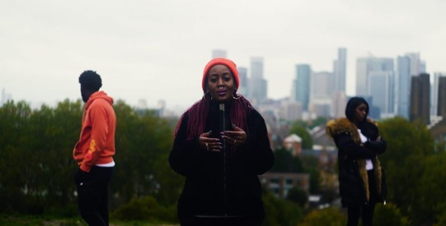
Lady Unchained’s mission is to prove that there is life after prison. Through poetry she tells her own personal story and the stories of those with experience of the criminal justice system that are often left untold, because of shame, stigma and negative labels. She hosts Unchained Nights in partnership with Artsadmin at Toynbee Studios, a night of inspirational storytelling, through poetry and music, performed by artists with lived experience of the justice system, and BBC Radio 4 aired a documentary, Unchained, in July 2020 about the rise of short-term prison sentences for women.
The Forgotten People is supported by EU funding from the Creative Europe programme of the European Union, through Artsadmin’s participation in a collaborative European project called BE PART, which explores the ethics of participatory arts practice.
ENDS

NOTES TO EDITORS

PRESS CONTACT
For more information, interviews and other images please contact Katie Haines: katie@artsadmin.co.uk / 07714 304 434

LISTINGS INFORMATION
The Forgotten People: Lady Unchained and Tracy Kiryango in conversation
28 January 2021
5–6pm, Online via Zoom, Free
Captioned and BSL available.
Booking link: https://www.artsadmin.co.uk/events/the-forgotten-people-lady-unchained-and-tracy-kiryango-in-conversation/
For booking and access enquiries, email boxoffice@artsadmin.co.uk

IMAGES
Promotional images can be downloaded from the following link: https://www.dropbox.com/sh/47etf199lqskc24/AAAet_vGNX2BxcvJLoeD_juJa?dl=0

CREDITS
Written and performed by Lady Unchained
Cinematographer and editor: Tracy Kiryango
Commissioned by Artsadmin, with support from BE PART through the Creative Europe programme of the European Union.
BIOGRAPHIES

LADY UNCHAINED
Lady Unchained co-hosts for National Prison Radio’s show We Are Straightline, a show about getting out of prison and staying out of prison. She has worked with a number of charities, including Body and Soul Charity, Working Chance and Safe Ground. In 2016, Lady Unchained won an open mic competition and used the prize money to help fund a trip to Uganda, where she visited inmates in two separate prisons talking to them about their experience of prison in Africa.
She has featured on TEDxLondonWomen, BBC Radio 4, Good Morning Britain and Refinery 29.
www.unchainedpoetry.com Twitter: @UnchainedP Instagram: @unchainedpoetry

TRACY KIRYANGO
Tracy Kiryango is a filmmaker with over eight years of filming and editing experience. Tracy has a strong background in storytelling through film having written, directed and produced her own short films and worked previously on documentaries for The Telegraph, Express Newspapers, and TwoFour Broadcast. Tracy runs her own company, ASE Productions, where she collaborates with other creatives to make music videos, visual poems, behind the scenes videos- anything that gives her an opportunity to elevate her craft.
www.artstillexists.com Instagram: @karmicdelight

Artsadmin
Artsadmin is a producing organisation, which enables artists to create without boundaries, connecting bold interdisciplinary work with local, national and international audiences. The advisory service supports artists at every stage of their development with free advice and opportunities. In London’s East End, Artsadmin has established at its base Toynbee Studios, a centre for the creation, development and presentation of new work, where, in the rehearsal, performance and meeting spaces, new talent is constantly nurtured.
www.artsadmin.co.uk @artsadm

