Accessible Marketing Guide

Contents
- Introduction and the basics
- Websites
- Print and text
- Accessible formats
- Social media
- References and resources

Authors
The original version of this document was published in 2016 by Jennifer Tomkins, former Head of Marketing and Development, Artsadmin and Jo Verrent, Senior Producer, Unlimited. This latest version was updated in 2020 by Grace McDonagh, Marketing Officer, Artsadmin, with support from the Unlimited, Artsadmin and Shape Arts teams.
This is a live document and we want to keep it as up to date as possible. Please get in touch via info@unlimited.org.uk if you have any questions, suggestions or additions.
Unlimited is an arts commissioning programme that aims to embed work by disabled artists within the UK and international cultural sectors, reach new audiences and shift perceptions of disabled people. Unlimited has been delivered by the disability-led arts organisation Shape Arts and arts-producing organisation Artsadmin since 2013, and is currently funded by Arts Council England, Arts Council Wales, Creative Scotland and British Council. Since 2013, Unlimited has awarded over £4 million to 280 ambitious disabled artists and companies, which have been seen by or engaged with more than 2.6 million people globally and online.
www.weareunlimited.org.uk
Follow @weareunltd on Twitter | Instagram | Facebook
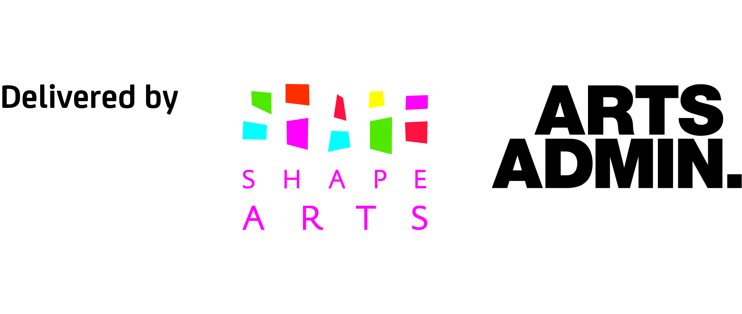
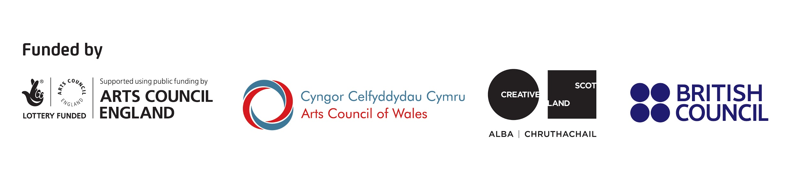
Introduction

Accessibility means the degree to which a product, device, service, or environment is available to as many people as possible. When we talk about accessibility we are talking about removing the barriers preventing someone from accessing something.

In marketing this translates to our websites, our print or marketing materials and our social media as well as the written copy, images, videos and other media we use across all of these platforms.

Why make your marketing accessible?
It is our responsibility to design and carry out our marketing activity in ways that mean it is useable to as many people as possible, irrespective of context. Some people may consider accessibility an afterthought but it should be built in from the start as it benefits a larger group of people.

Accessibility most directly helps disabled and older people but all audiences benefit from inclusive design. Examples of this might be how high contrast screens help people see in bright sunlight, how people watching videos on noisy trains need subtitles, simple use of English helps those who don’t use it as their first language and clean design aids readability for all - designing for a disabled person can also benefit many others.

Around a billion people worldwide (that’s 15% of the global population) have some form of impairment and including temporary and situational disabilities in these numbers increases the number dramatically. There are exciting and attractive ways to make your events, exhibitions and performances more accessible, and ultimately serve a more diverse audience. Keep each other in check and accountable, accessibility is not an afterthought, it's a team responsibility, a social responsibility and a legal requirement in line with the Equality Act 2010, which protects people from discrimination in the workplace and in wider society.

The basics

Get it right from the start
Access for disabled people is about your organisation making its main marketing materials accessible, it is not just about alternative formats.

Don’t assume
Not all disabled people see themselves as disabled. Often older people, who have a range of impairments would never think to look at a page labeled with ‘disability’ or ‘accessibility’, not all disabilities are visible and not all disabled people want to explain their disability, so do not marginalise access information.

Mind your language
Create a language guide so that everyone in your organisation uses the same words in the same context – and more importantly know why they are doing so. Disability Equality Training for your organisation will help this exercise. In the UK, most of the arts sector find it more acceptable to say ‘disabled person’ than ‘person with a disability’ according to the social model of disability.

Plain English
Check the reading age of your copy for free in Microsoft Word to get your Flesch-Kincaid Grade Level (the school year your writing is suitable for). You should aim for 8 on the Flesch-Kincaid scale (which is the average reading age of 13 years old).
Plain English Campaign have resources for this.

Writing style
- Be concise and use short, simple sentences.
- Try not to use phrases that could be confusing like double negatives.
- Consider using bullet points and numbering if there are lists of more than three things. Break up longer text with regular section headings and, for longer documents (like this one), include a table of contents.

Alternative text for images and other media
There is an option to add ‘alt text’ on social media platforms like Facebook, Twitter and Instagram and on most website editing platforms/CMS. Alt text describes the image for blind or partially sighted people who might be using screen readers (a form of assistive technology often used by people who are visually impaired, or with dyslexia). See the resources on page 7 for more on how to write alt text and best practice.

Content notes
Content notes, also known as ‘trigger warnings’ or ‘content information’, are notes written at the top of content to alert your audience to themes within the work. They can be used to notify your audience of issues that may potentially cause distress so they know ahead of time and can avoid it if they choose to.

Email signatures
Your email signature is constantly in use so it is important that this adheres to accessibility standards. This means size 12, clear font which is not italicised, capitalised or using a light colour that is less visible. You may choose to include your working hours and pronouns. As Stonewall says, pronouns are “words we use to refer to people’s gender in conversation - for example, ‘he’ or ‘she’. Some people may prefer others to refer to them in gender neutral language and use pronouns such as they/their and ze/zir.”
If you work outside the usual working hours of the arts sectors (starting 9-10am, finishing 5pm-6pm), this is a good way to set boundaries about when you can reply.

Ask
- Consult with disabled people, this is not just the key to getting it right but to building audiences too.
- Ask for feedback, then act on it. Invite people to ask for different formats and don’t make it sound like a chore. For example, say ‘please ask us for this information in alternative formats’ rather than ‘this information is available in alternative formats upon request’.
- Know which alternative formats you can supply, how long it will take you to produce them and that you may need some extra budget to create them. Be aware that you are required by law to do this (Equality Act 2010).

Websites

Some basic things to consider when checking whether your website is accessible are:
- Make sure you have alt text for images and captions for videos.
- Many screen readers do not read italic formatting so avoid this.
- Can you navigate your website through the keyboard only?
- Can you see where you are on the screen by just navigating your keyboard?
- Is the font size above 12 as standard and can people easily enlarge? Consider incorporating a font enlargement ability. Is text still readable using larger font sizes?
- If you change the display colour to greyscale can you still read everything?
- Choose a page and check whether it looks the same using a range of web browsers.
- Try using a voice browser or a text browser (free options available online)

How can we go about making our websites accessible?
- If you are creating a new website or developing an existing one, build access into your web design brief from the start. Check out the Worldwide Web Consortium’s (WC3) Web Accessibility Initiative (WAI and their A, AA or AAA rating) and see how good or bad your existing website is with their evaluation tools.
- Conduct research: Interview people to better understand what their abilities are, how they are using the interface and how something may exclude or include them and a sense of their barriers when they interact with technology.
- Make sure you review your design with experts as well as peer reviewing designs and people outside of the project for an unbiased perspective.
- Once you’ve gathered research you can use this to create an idea of potential users, including these accessibility needs.
- Then you can start adding solutions with web developers when you know who you are designing for.
- Consider how best to incorporate design principles over touch, sight and movement content, structure, colour, typography and navigational design.

Hyperlinks
- Avoid using ‘click here’, instead, describe where the link is taking someone, e.g. hyperlink the phrase ‘more details on our next show.’
- Make sure there is space between menu titles and other links.

Uploading documents to your website
- Include both Word documents and PDFs as downloads because some screen readers cannot scan PDFs.
- Give the files sensible, readable names like "Application FAQ" instead of "Appl1122_b" as this helps blind or visually impaired people using a screen reader.
- Plain text documents are simple, and don't contain any images, rich-text formatting, or embedded links, depending on how you design your documents, this may not be necessary. While these documents don't include any fancy design elements, many people who use screen readers prefer them. It’s still good to do all the headings in one size and all the body text in another, if these are styled right it helps screen readers and text to speech to break up the content so it's a bit more listenable because many of them can recognise what's a title, section header and/or body text.

Printed materials
Printed marketing communications can be attractive and accessible. Keep your designs clear, simple and clutter-free.

Imagery
- Illustrate your commitment to equality with images that include disabled people and show off your access provisions.
- Do not put text over images as it makes it hard to read; and screen readers cannot read it.

Text size and formatting
- 12 point font is the minimum standard, with 14 point being advisable – this includes image captions and logo credits. It’s not just visually impaired people who benefit from this, many people struggle with excessively small type.
- Avoid italics and use bold instead. Italics are not accessible for people with visual impairments or dyslexia: almost two million people in the UK live with sight loss; 10% of the population have dyslexia.
- Try not to use serif or ‘handwritten’ fonts or capitals for long, continuous blocks of text, they are hard to read,
- Avoid block capitals or using all lower case in continuous blocks of text/prose text for the same reason
- Left align text, without justification and avoid using lots of columns.

Colour contrasts
- Contrast between coloured backgrounds and overlaid text should be at least 25%. This means no pale colours on a pale background.
- Using a single colour background rather than a multicolour or patterned background can be helpful.
- Think too about impaired colour vision (colour-blindness) and the colours that are most often confused, e.g. red/pink and green (see resources on page 7 for more on this). Adobe software has in-built features, which can simulate colour blindness so designers can proof artwork from the perspectives of different types of colour blindness and check the accessibility of a colour palette.

Paper
- Use matte paper as gloss finish is often too reflective. Low paper weights show text from the reverse and can be too flimsy to hold.
- Complex folds in leaflets can obscure text and images, but also complicated folds in leaflets can make it hard to open/unfold and fiddly to put back together (i.e. like the concertina fold of a printed map).
- Size matters – if the piece of print is too big then it’s hard to unravel; too small and you won’t be able to fit a large enough font size.

Accessible formats

Large print
- The default for large print is 18 point, with 16 point as the minimum.
- 24 point is sometimes known as ‘giant print’.
- Avoid fancy fonts, italics and large blocks highlighted or in capital letters.

Audio recordings
- You can create audio versions of your marketing materials, which can then be downloaded from or embedded in your website.
- Ensure each recording begins with a clear description of what it is you’ll be covering in that recording.
- Break large documents into separate files for each chapter or section.
- Listen to an example of an audio recorded blog here: https://www.seasonforchange.org.uk/meet-the-team/
- Provide a transcript with your audio description (ideally not a PDF but in text or a Word document download. You can use online software to auto-generate transcripts of audio files, although they may need some editing afterwards to check for typos).

Braille
Many blind and visually impaired people are now using sound based formats in preference to braille, fewer than 1% of the two million visually impaired people in the UK are users of Braille. Organisations should work with their local populations of blind and visually impaired people to determine which formats best suit their needs.

Braille is designed to be read by fingers rather than eyes. It’s a code based on six dots, arranged in two columns of three dots. There are two grades of braille:
- Uncontracted (previously Grade 1): a letter for letter translation from print, includes the alphabet, numbers and punctuation marks;
- Contracted (previously Grade 2): a condensed version reducing the size of Braille documents by about 25 per cent, generally increases reading speed. You can buy the kit and produce Braille in-house or you can use an agency to help you - search for ‘text to Braille translation.’
Easy Read Guides
- For more permanent pieces of print (such as a map of your venue or a guide to a permanent collection), you could create an Easy Read Guide.
- Easy Read information is designed for learning disabled people who like clearly written words with pictures to help them understand. You can use a specialist agency to create an Easy Read Guide or you can create your own using templates and guidance available online.
- Easy Read Guides assume some level of reading so you could also supply other accessible information formats like audio or video.

Social media
We cannot control external websites’ commitment to accessibility but we can flag if a site is not accessible and this feedback can contribute to a change in platforms taking steps towards better accessibility.

Facebook
- Facebook automatically generates alt text for images but you may wish to edit this to provide a better description of the image. How to edit alt text (via Facebook).
- If you’re uploading videos via the Facebook video platform, you can supply captions. This is important for accessibility but also because many people use social media without sound turned on so captions makes content accessible to a broader audience. How to add captions to a video (via Facebook).

Twitter
- Use the alt text option to briefly describe your image.
- Avoid whole tweets or sentences written in capital letters.
- Make sure images used are additional and not integral to your tweets e.g. A photo of a previous performance when promoting a new one is fine, but not an e-flyer containing the text information.
- Some emojis are fine but too many aren’t good for screen readers.
- The first letter in each word of a hashtag should be capitalized, so a screen reader can differentiate the words and it is easier to read. For example: #AccessibleMarketingGuide

Instagram
- Use the alt text option to briefly describe your image.
- Do not caption everything in uppercase, this is harder to read generally, and also harder for a screen reader to read.
- Make sure you have captions for your video content, this should be budgeted in at the start of commissioning film content and it is much easier to do this at the point of editing rather than retrospectively. There are a few apps that automatically transcribe what you say, like Clipomatic (for iPhone) and Autocap (for android). You can also do this by overlaying text on Instagram stories, typing out what you say, or by writing in the description of a main feed post.
- For Instagram Stories, avoid cursive (joined up handwriting style) fonts and writing in all capital letters, sentence case is best.
- Avoid using text speak in Instagram Stories for screen readers.
- If you are posting an existing film file which is not captioned, then you should write the transcript in the description of the video.
- Some emojis are fine but too many aren’t good for screen readers.
- The first letter in each word of a hashtag should be capitalized, so a screen reader can differentiate the words, and it is also easier to read. For example: #CardsForInclusion

YouTube
- Create both a captioned version and an audio-described version of your film content if you can. You will need to budget more for this and should use an experienced audio describer. Here are examples of audio described films on Unlimited’s YouTube channel.
- You can also create a BSL version for BSL users by sending your videos to a BSL interpretation service. Here is an example of BSL interpreted films on Unlimited’s YouTube channel.
- If budgets are really tight, YouTube does provide its own subtitle option. Turn this on and check that they make sense (they are often wrong) and edit. Youtube also gives you the option to transcribe your own captions.
- The simplest option is to provide a transcript of your video as an alternative. This can be auto-generated using online software or typed out as you listen to it.

Please do get in touch via info@unlimited.org.uk if you have any questions, suggestions or additions to this guide. This is a live document and we want to keep it as up to date as possible.

References and resources

The Basics
- Unlimited has useful resources on accessibility:
https://weareunlimited.org.uk/resources/
- Unlimited’s delivery partner Shape Arts has a list of resources on accessibility: https://www.shapearts.org.uk/Pages/News/Category/resources

- Read about the language of disability and the social model: http://www.disabilityartsonline.org.uk/why-we-are-disabled-people-notpeople-with-disabilities
- Watch a captioned and audio-described animation about the social model: https://weareunlimited.org.uk/social-model-disability-animation/

- Making written information easier to understand for learning disabled people: https://www.inspiredservices.org.uk/wp-content/uploads/Government-EasyRead-Guidance.pdf

- Dyslexia-friendly style guide by British Dyslexia Association: https://www.bdadyslexia.org.uk/advice/employers/creating-a-dyslexia-friendly-workplace/dyslexia-friendly-style-guide

- Disability Equality Training from Shape Arts: https://www.shapearts.org.uk/news/training

- Writing alt text, examples and best practice:
https://moz.com/learn/seo/alt-text
https://www.rnib.org.uk/rnibconnect/web-accessibility-people-disabilities

- A guide on designing for colour blindness: https://www.abetterimageprinting.com/resources/the-ideas-collection/designing-for-color-blind-viewers/

- Plain English Campaign has useful resources and services for providing clear and concise information:
http://www.plainenglish.co.uk/

Accessible formats
- From the UK Association for Accessible Formats (UKAAF), a guide to creating clear print and large print documents: https://www.ukaaf.org/wp-content/uploads/G003-UKAAF-Creating-clear-print-and-large-print-documents.pdf

- Guidance on braille from Royal National Institute of Blind People: https://www.rnib.org.uk/braille-and-other-tactile-codes-portal-writing-and-producing-braille/transcribing-text-braille
https://www.rnib.org.uk/services-for-businesses

- For more description of audio formats: http://www.rnib.org.uk/information-everyday-living-reading/audio

- Transcribe audio and video content into text, captions and foreign captions using this website:
https://www.rev.com/
https://otter.ai/

Website Accessibility
- Online Perspectives on Web Accessibility and check your website accessibility:
https://www.w3.org/WAI/

- Check your website for accessibility: https://inviqa.com/blog/implementing-accessibility-10-mistakes-avoid

Social media
- Making Facebook Live videos accessible with real-time captions: https://twitter.com/Adam_Zed/status/1243117457306521601

- For the latest on Facebook accessibility: https://www.facebook.com/accessibility/videos/1082033931840331/

More access
- A practical guide for designing inclusive exhibitions by National Museums of Scotland: https://www.rnib.org.uk/sites/default/files/EXhibitions_for_all_NMScotland.pdf

- Watch the Unlimited films on running accessible events, commissioned by Spirit of 2012: https://www.youtube.com/watch?v=3_i5EjJsmE0

- Watch the Unlimited films on accessible recruitment, commissioned by Spirit of 2012: https://www.youtube.com/watch?v=7EnYGcIL6j0

- Making your conference presentation more accessible to blind and partially sighted people from VocalEyes:
https://vocaleyes.co.uk/services/resources/guidelines-for-making-your-conference-presentation-more-accessible-to-blind-and-partially-sighted-people/

- Accessible remote guidance working from UCL: https://www.ucl.ac.uk/human-resources/news/2020/apr/accessible-remote-working-guidance

- Guidance on online working and online safeguarding From AMA culturehive:
https://www.culturehive.co.uk/resources/guidance-online-working-and-online-safeguarding/

