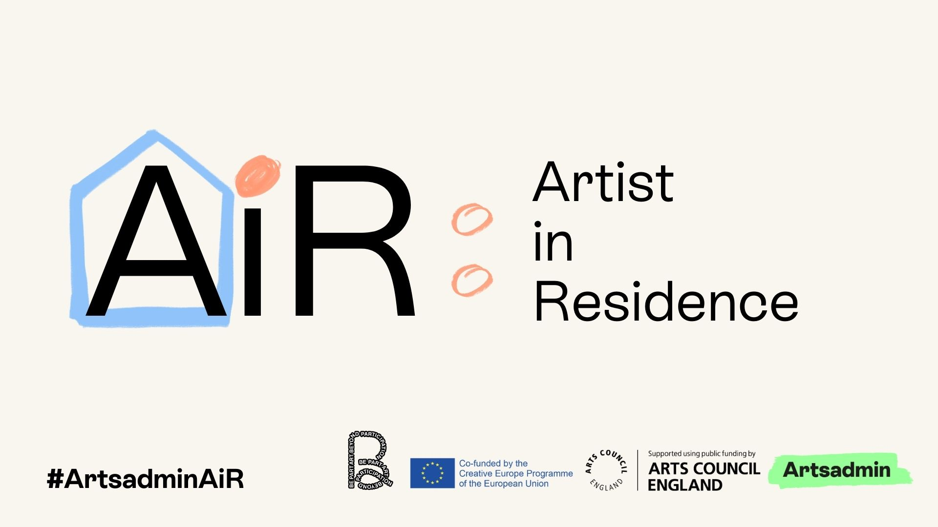
Artsadmin presents: Artist in Residence (AiR)

AiR is a unique residency pilot project and employment contract for one artist to join Artsadmin from September 2023 – August 2024 for a year of deeply-embedded artistic research within our team and the local communities of East London.

Application Pack
General Enquiries: creativesupport@artsadmin.co.uk
Access Support Enquiries: access@artsadmin.co.uk

Introduction
The reality of life for performance-making artists in London at present is stark. Rents are rising. The cost-of-living crisis continues, as does the hostile-environment. Public funding for arts practice has been in decline since 2009.

At the same time, we are experiencing a shift in the way artists want to work with collaborators; understanding that artists and the communities they work with desire deeper, more meaningful relationships. Relationships that are equitable and mutually rewarding. Building trust takes time, and time is often the most challenging resource to allocate.

Artsadmin have been taking part in many conversations internationally, for years, about the ethics of co-creation and collaboration, and, as a team of producers, motivated and always informed by our work with artists, we have found ourselves continually troubled by the absence of artists’ voices from these conversations.

We continually hear feedback from artists about the inequity between salaried arts workers and precarious freelancers that exists in the arts sector. Why is it taken as a given that artists must live a precarious freelance life, while some producers, administrators and other arts workers are entitled to a salary and benefits?

While we cannot fix the entire sector, we can make changes in our own organisation.

We are interested in supporting long-term deep artistic research, building sustainable trusting relationships within the diverse communities that live and work in the Aldgate, Spitalfields, and Whitechapel areas; and in supporting an artist with the kind of contract that allows them the time to develop collaborative practice and research, and allows us to form a relationship with them at the same time.

And so, we are initiating a pilot project, AiR, where we seek to appoint an artist, via open call, to work with us for one year, and develop their practice in the context of our home and surroundings.

This opportunity won’t suit everyone. It’s for someone who wants to work with Artsadmin, and further their ideas for projects within a collaborative context, with communities of place and interest in East London. It’s geared towards artists whose practice might sit between forms, but usually involves performance or liveness. They will also have experience of working with communities, either as part of their research, or in the creation of their work.

What you can expect from us:

1 year (September 2023 - August 2024) residency embedded at Artsadmin to include:
- Contract, salary and benefits as follows:
- 12 month fixed-term contract for 3.5 days per week* (0.7 FTE). *Flexibility on this is detailed below.
  - Salary of £22,400 (£32,000 pro rata) per year before-tax on a 0.7 FTE (3.5 days per week*)
  - Payment, national insurance and tax administrated by Artsadmin’s payroll
  - 14 days paid holiday (20 days pro rata)
  - Pro rata paid bank holiday entitlement
  - Pension setup for you with contributions from Artsadmin of 4% of your salary on the basis you contribute 5% of your salary through payroll too.
  - All other staff benefits such as the Cycle to Work Scheme, health cost reimbursement benefit, and more.
- A permanent desk in the Artsadmin office
- Access to at least 4 weeks of rehearsal studio space at Toynbee Studios to support your residency research. More will be subject to availability.
- Support from across the Artsadmin team, including but not limited to the artistic leadership and Producing team. This could include:
  - Introduction to networks, groups, and individuals within local communities
  - Access and involvement in all aspects of the Artist Support programme including advice/planning and strategic development of both your career and/or a specific project/workshops etc.
  - Producing and fundraising support should you want to develop a project that has evolved directly out of this residency period with Artsadmin (not an expectation)
  - The possibility of sharing work publicly at Toynbee Studios if you would like to (not an expectation)
- We will be excited to champion your practice and research, and be curious about your discoveries, offering dramaturgical and pastoral care support throughout your residency.

*It need not necessarily be 3.5 days a week every week. This can vary, depending on your other work. We will pay the salary monthly, but the time commitment will be defined by you in coordination with us in order to honour other work/commitments that you have.

What we will expect from you:

- You will base yourself at Toynbee Studios either 3.5 days a week, or full-time 36.5 weeks out of 52, from September 2023 – August 2024. This can be flexible, and the exact dates will be decided in collaboration with you in order to fit around other projects and opportunities you might have during that year.
- Your residency research should involve people who live and work in East London.
- You will become part of the Artsadmin team, attend staff and other relevant meetings.
- You will attend regular monthly catch up sessions with the Artsadmin leadership and the producer working with you.
- You will engage with the wider artistic programme at Artsadmin on occasion (perhaps as a guest artist in our Artist Support programme, engaging with Artsadmin Youth projects, or taking part in a live or digital talk event. This should take up no more than 10 days of your residency in total).
- You will be excited to share your practice and research with the team at Artsadmin so that we can explore what co-creation in our hyperlocal context means for all of us.

Criteria

You should apply if:

- You have an active interest in and a curiosity about the local communities in East London, and a desire to connect with those communities. Your approach to working with people will be rooted in mutual respect and ethical collaboration.
- You understand and are interested in Artsadmin’s work as a producer of projects across and between disciplines, social and climate justice, in local, national and international contexts, and an interest in peer-to-peer artist support.
- You are committed to community building, and community-led change.
- You plan to engage and collaborate with local people during your residency in a way that is meaningful and relevant to your experience. We welcome ideas rooted in any discipline that are bold, fierce, imaginative, participatory, radical and disruptive to mainstream ways of thinking & doing.
- Your practice is primarily performance-based, collaborative and live.
- You have built relationships with at least one community of place or interest who are willing to share their experiences of working with you.
- You hold the right to work in the UK and are able to evidence this through a British or Irish passport, a suitable visa document or a share code from the EU Settlement Scheme.

Selection Process

Phase 1
We will ask you to send us a statement in video, audio, written or mind map form that answers these questions:
- Tell us about a recent creative project you’ve worked on, and why it was important to you as an artist.
- Tell us about a recent project you’ve worked on within a community of place or interest, and how it demonstrates your process of working collaboratively.
- Why are you interested in our locality in particular?
- Why are you interested in working with Artsadmin?

Additionally, we will ask you to submit a letter or video or audio recording of recommendation from a member of a community with whom you have worked before. This should be of no longer than 750 words or 5 minutes (shorter is fine!) describing how they know you, what the project you worked with them on was, and how that project impacted them.

We will also ask you to provide 1-3 web links to documentation of your work (written, audio, images or video).

Our application portal will open at 10am on April 3rd
Deadline for Phase 1 will be midday on April 17th

This phase will be reviewed by 10-12 Artsadmin team members. Each application will be read by two readers, one of whom will be from our Producing team. The readers represent a diversity of ages, nationalities, cultural backgrounds, and disabled and non-disabled experiences. Before we open the portal, we will publish names and short bios of all readers.

Phase 2
We will invite 20 artists to submit a more detailed application, all formats accepted (video, audio, written or mind map form.)
We will ask for:
- A brief proposal for how the 12 months might operate
- Answer to the question: Why now?

This phase will be reviewed by a team of 8 people: 6 Artsadmin staff, 1 independent artist, and 1 representative from local communities with whom Artsadmin has worked before.

We will reach out to the 20 artists on May 15th
Deadline for Phase 2 will be June 5th

Phase 3
We will invite 3 artists to meet with Artsadmin for:
- An interview (virtual or in-person)
- A chance to lead a 30-minute workshop or talk (either live or virtually) with a group based on their Phase 2 proposal
- A more detailed proposal of their 12-month plan

All questions and preparation guidelines will be sent in advance.

Selection panel will be made up of 8 people: 4 from Artsadmin and 4 externals (2 artists and 2 local community members.) At least one of the external people will have been part of the Phase 2 reading team. We will also have a non-voting chair present to oversee the process.

All artists invited to Phase 3 will be paid for their time. We estimate the fee to cover two prep days at £100 per day and £200 for the interview day for a total of £400 per applicant.

We will reach out to the 3 artists by June 13th
Interviews will take place on June 19th
The selected artist will be notified by June 23rd

Information sessions
We require that anyone considering applying attends an information session.

This will allow for a deep explanation of our criteria and selection process, answer questions, and invite you to select out if this not the right opportunity for you.

If you are not able to attend any of these dates, we’ll ask you to watch a recording of the session.

- March 20th, 7pm - 8pm (Online, BSL interpreted)
- March 26th, 11am - 12pm (Online)
- March 29th, 1pm - 2pm (Online, this session is specifically holding space for Black people and members of the Global Majority)
- April 4th, 4:30pm - 5:30pm (in person at Toynbee Studios, Artsadmin Canteen)

