Senior Trusts & Foundations Manager Recruitment Pack

For access queries, including any alternative formats, or if you have any difficulty completing an application, please call 020 7247 5102 or email access@artsadmin.co.uk.
To apply, please see the guidance on the next page for submitting a CV and cover letter or alternatively a video or audio file.

Deadline for applications: Monday 15 April 2024, 10am
First interviews: Thursday 25 April 2024 on Zoom
Second interviews: Tuesday 30 April 2024 in person at Toynbee Studios, Aldgate

Thank you for your interest in Artsadmin.

Please refer to the Senior Trusts & Foundations Manager job description and person specification in your application.

This application pack contains:
- Applicant guidance notes (p.2)
- About us (p.4)
- Senior Trusts & Foundations Manager job description (p.8)
- Senior Trusts & Foundations Manager specification (p.13)

We are seeking a Senior Trusts & Foundations Manager to work in direct dialogue with the Artistic Director and Executive Director as our Joint CEO’s, including feeding into and then delivering our fundraising strategy. This is an exciting moment to join Artsadmin following the appointment of Raidene Carter as our new Artistic Director. With the support of our Communications & Development Officer and other external professional advisors and bid writers, you will enjoy working directly with producers who are also fundraisers to plan the projects, applications and outcomes that will garner investment and deliver our vision.

The ideal candidate will hold expertise in developing relationships with funders, with a particular focus on trusts & foundations and some corporate, public, and partnership fundraising. You will have a track record of securing successful mid and large-scale fundraising applications, as well as feeding into or shaping a multi-year fundraising strategy. You may be looking for a step up or a shift in your career to have more input at a strategic level without the demands of running a large development team, with the ability and freedom to work across an entire organisation.

Kind regards,

Raidene Carter and Ben Cooper-Melchiors
Artistic Director and Executive Director
Senior Trusts & Foundations Manager
APPLICATION GUIDANCE NOTES

Please follow the checklist below to ensure you fully complete your application.

What? | Why? | Completed?
Read Guidance Notes | To ensure you send the best application you can, so you’re more likely to be shortlisted.
Research Artsadmin | This will tell you about who we are and the work we do: artsadmin.co.uk
Read the Job Description | This explains the key activities of the role. You need to be sure that you have the potential to fulfil the activities outlined and are interested in the full range of the role. It will also detail the areas of expertise you should highlight your experience of in your application form.
Read the Person Specification | These illustrate the minimum requirements for the role. It is important that you clearly demonstrate these in your application. The desirable requirements are indicative of potential specialities that are good to reference but not essential.
Questions about the role? | Interested applicants can have a confidential conversation about the advertised role prior to applying. We particularly encourage people who are thinking they could do it, but are not sure, to have that initial conversation. Email recruitment@artsadmin.co.uk to arrange a call with the Executive Director or Artistic Director or alternatively email vicki@achates.org.uk to speak to Vicki Grace at Achates Philanthropy as an external advisor.
Complete an application by CV and cover letter (or video/audio) | Please apply by telling us, either in writing of no more than two pages or in a video or audio file of up to 5-minutes in length:  - Why this post is the right next move for you, what you can bring to Artsadmin, why it excites you and what you hope to gain from the post  - Details of the qualities and experiences you would bring to the role and how that meets the person specification  - At least 2 examples of successful fundraising work that aligns with the job description including an indication of the budget and your role in this  - Earliest available start date  - The names of two referees (only contacted after seeking permission)  If you submit a video or audio file, we may transcribe these for the selection panel to have the option to read them. Please also note, a written task will be required at the first interview stage for assessment against the person specification.  Please include your CV of no more than two pages. Remember to include all relevant experience including paid and voluntary work.  Complete the Equal Opportunities Monitoring form, which is anonymised and separate to your application, and not accessible to the selection panel. As such, if you identify as part of the Global Majority or are disabled and would like to declare this for assessment as part of our policies outlined below, let us know by email when applying.
Submit your application | You will receive a confirmation email. If you have any difficulties with your online application, contact us 020 7247 5102 or email recruitment@artsadmin.co.uk  Deadline: Monday 15 April, 10am. We cannot accept applications after this time.

ABOUT ARTSADMIN

Artsadmin creates the conditions for art to explore the spaces in-between.
Our work and projects explore the areas between social justice and environmental justice, the hyper-local and the international.
VALUES-DRIVEN

Artsadmin works with artists, communities, and collaborators in the development of creative work and conversations. Ensuring the success of these requires us to be led by our values, and to live them across everything we do.
We nurture vision from artists at all stages of their careers, with care and support
We take action to make projects happen locally, nationally, and internationally with creativity and ambition
We cultivate connection, with and in-between artists, communities, programming partners and funders with generosity and humility
We are actively interested in progressing equity in the projects we produce and the ways we work with commitment and empathy.
WHAT WE DO

We are a collaborative partner, working with artists as they explore and develop new projects, contexts, and ways of working. Everything we do is part of a unique curated artistic programme, from one-off hour-long creative support sessions at our east London home Toynbee Studios to multi-year global partnership platforms.

HOW WE DO IT

Everything we do is project-based. Some are artist-led, and some are conceived and led by Artsadmin. We work to develop and produce these projects and, with venue and festival partners, bring them to audiences locally and globally. At its heart, our work is about collaborating with artists, so their projects find the right context, partners and support.
We champion projects that speak to the ‘here and now’ really clearly, where artists are asking questions that feel urgent and essential. We value projects that align with our long-standing insistence that the arts have something to say about the climate emergency and social injustice. We are drawn to projects with an intuitive and rigorous enquiry rather than those making statements about the way the world is or should be.
The work we produce is neither defined nor confined by any one particular artform. We produce creative, risk-taking projects that connect with the DNA of Artsadmin and the post-punk political context in which it was founded in 1979.

OUR PROGRAMME
We work across 5 main areas:
Projects — We curate, develop and produce works with artists that connect with audiences locally, nationally, and internationally
Platforms — We develop and deliver ongoing series and multi annual programmes, often in partnership, that progress our artistic agenda and drive important conversations.
Portals — We make space to share knowledge, expertise, and insight to further ways in and ways forward in our sector for artists and arts-workers.
Pilots — We enquire, explore, and innovate to address gaps in our field of enquiry, and find new models, ways of working and tools that push these forward,
Place — Artsadmin’s home is Toynbee Studios in the heart of Tower Hamlets; a creative eco-system that houses other arts organisations, provides accessible studio hire, and a welcoming, creative canteen. We use our spaces to deepen understanding, engagement, and relationships in our hyperlocality through our engagement and public programmes.

OUR FINANCIAL MODEL

With an approx. £1.5m turnover, we currently receive 28% of our funding from Arts Council England as a National Portfolio Organisation (2023-27) and 25% from earned. 47% fundraised income across public and private sources including for artist projects and from partner contributions. Of the latter income, 10-15% of turnover represents our organisational fundraising target.

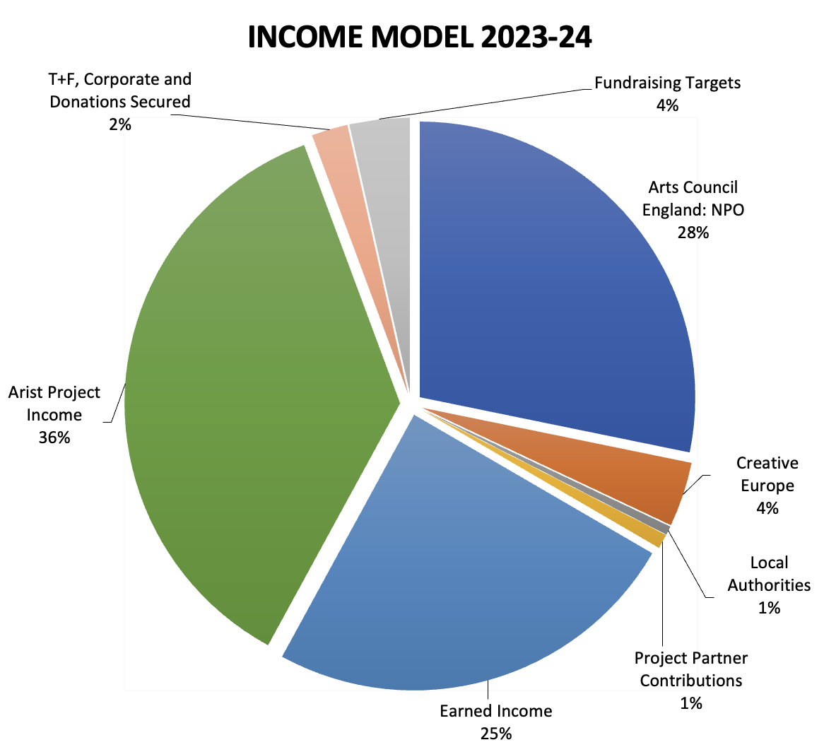

Other recent funders include Bloomberg, Jerwood Foundation, Creative Europe, City of London and Aldgate Connect BID.

Additional recent capital funders not represented in the chart above include £497,000 from Arts Council England, LB Tower Hamlets, Greater London Authority, London Legacy Development Corporation, Foyle Foundation, The Linbury Trust and Theatres Trust.

Our earned income is made up of studio hires, office sublets, consultancy, partnership contributions, and artists’ project management fees*.

*Artist project fees are drawn from individual project budgets which we produce on behalf of artists and that our programme team fundraise for from a range of sources, as separate to our organisational fundraising strategy held by this role. In the chart above, the income for artist project budgets is represented as the green section which is approximately 36% of our annual income.

For our most recent set of statutory accounts 2022-23, see here.

OUR TEAM

We are a friendly team comprising around 23 people where everyone’s contribution is valued.

As a currently 50% white organisation, we want to continue developing our anti-racism strategy as part of a commitment and ongoing process to create a diverse and inclusive workplace.

Artsadmin is a London Living Wage employer.

OUR RECRUITMENT APPROACH

We are particularly interested in hearing from people who are underrepresented in the sector, such as those who identify as D/deaf and/or disabled, those from low socio-economic backgrounds, people of African or Caribbean heritage, South Asian heritage, East Asian heritage, West Asian heritage, Central Asian heritage, South East Asian heritage, people of Middle East and North African heritage* and those who have experienced racism. By the term ‘those who have experienced racism’, we are referring to individuals who have experienced discrimination based on the colour of their skin, race and/or their culture. *#BAMEOver – A Statement for the UK, Sept 2020

For the recruitment of this role, we are committed to ensuring that there is:
- A person of colour on the interview panel
- Interviews guaranteed for those who identify from the Global Majority* and meet our minimum essential criteria in the person specification.
- A chance to meet some of the team at interview stage to give insight into the organisational culture, as well as a chance to ask questions outside the interview

And that, once in role, any successful candidate who identifies as part of the Global Majority will have access to a qualified coach who also identifies as such, to provide support for working in a majority-white team during their first year at Artsadmin.

In using the term ‘Global Majority’ we refer to people who identify as Black, Asian, Brown, dual-heritage, indigenous to the global south, and or have been racialised as 'ethnic minorities'. (Rosemary Campbell-Stephens, 2020)

Access support is available for all applications, including alternative formats and tailored support. A summary of all of our access support for candidates as well as employees is available here:
https://www.artsadmin.co.uk/about/jobs/#accesssupport

If, for access requirements, you’d prefer to meet one of our team or talk through these guidelines please contact access@artsadmin.co.uk; or call 020 7247 5102.

POLICIES AND MORE INFORMATION
Find out more about Artsadmin, our policies, and how we work.

Senior Trusts & Foundations Manager
Job Description

Responsible to: Executive Director & Artistic Director
Additional reporting: Board of Trustees
Salary: £43,000 – £46,000, depending on experience
Type of contract: Full time, 5 days a week (4 days a week on a 0.8 FTE part time contract would be accepted)
Hours of work: 10am-6pm, Monday-Friday. No overtime will be paid, but time off in lieu can be taken for additional hours assigned in advance by a Director. Hybrid remote working for 20% of the week is automatically possible for all staff in alignment with Artsadmin’s Remote Working Policy. Requests for additional flexible working arrangements and/or ad-hoc requests are welcomed and regularly reviewed for all staff, with a guideline of maintaining most of our time in person as a team.

Holidays: 20 days, plus eight public holidays and a two-week, discretionary company closure over Christmas and New Year.
Probation Period: Six months
Notice Period: Three months

External Relationships: Trusts & foundations, local authorities, public funders, corporate funders, individual donors, Arts Council England, research councils, other funders and partners, culture sector networks

Internal Relationships: Producers, Communications & Development Officer, Communications Manager, Financial Controller

Benefits (post probation):
- 4% employer pension contributions, 1% above statutory minimum
- Health scheme, reimbursing medical costs including eye tests and glasses
- Contractual sick pay
- Travel card / Season ticket loan
- Cycle to Work Scheme / Tech Scheme
- Enhanced Maternity, Adoption and Shared Parental Leave Policy
- Additional holiday and childcare benefits for length of service

Purpose of the Role
- Devise, own and deliver the charity’s fundraising strategy with the support of the Joint CEO’s, ensuring the multi-year resilience of its fundraising function with a particular focus on trusts and foundations
- Advise on the strategic development of the communications strategy held and delivered by the Communications Manager and their team, with a particular view of reinforcing the fundraising strategy
- Advise on the strategic development of external relations that support these strategies

Context
This existing leadership role has been refined over the past few years to enable a clear focus on our fundraising strategy, developed with many perspectives and external advice.

We’ve worked to ensure the time, support, and remit to work directly with the Joint CEOs on the strategy and to build relationships across the organisation’s producing team has been put in place—to plan the projects, applications and outcomes that will garner investment and deliver our vision.

It is not expected that excellent expertise in every form of fundraising is required. Although we have sustained low level individual giving with coordination support for this in place, trusts & foundations alongside some corporate and public relationships will be key. We will aim to sustain freelance bid writing support and other external advice wherever possible, to complement and reinforce this role.

Duties include:

Strategy, Planning, Evaluation and Reporting
- Develop and deliver Artsadmin’s fundraising strategy in consultation with the Directors, trustees, staff, key stakeholders and consultants, as needed, in order to reach our annual and multi-year fundraising targets
- Ensure the ongoing development of Artsadmin’s story of change for our overall mission, vision and activity as well as case for support documents and stories of change for specific programmes
- Undertake prospect research directly and with the groups above
- Mobilise trustees, Directors and other key stakeholders in prospect identification and cultivation on a short term and long-range basis, as well as encourage trustee engagement in campaign support and donating directly to the charity. This includes reviewing and establishing a Development Committee including trustee and non-trustees.
- Maintain a multi-year fundraising pipeline as a management and reporting tool alongside the Directors and trustees, aligning and tracking the feasibility of the charity’s fundraising targets, prospects, and programme outcomes. Work with the Directors to align this to our business plan.
Evaluate Artsadmin’s development activity and provide accurate quarterly reports on progress to the Directors and the Board

Development
- Take responsibility for the annual fundraising target agreed and set by the Directors. This is around £120k in 2024-25 with an expectation for growth over time to c. £150-250k in line with the organisation’s wider strategy.
- Oversee management of Artsadmin’s fundraising campaigns, schemes and engaging events
- Cultivate prospects and nurture relationships with funders, in particular trusts and foundations, while also being able to support opportunities with local authorities, corporate partners and, on occasion individuals.
- Lead and write major applications
- Guide and oversee the Communications & Development Officer’s prospect research and small application writing, especially trusts, foundations, local authority and corporate application opportunities
- With the support of the Directors, liaise with key development partners including the Board of Trustees, Arts Council England, Greater London Authority, London Borough of Tower Hamlets, other east London local authorities, trusts, foundations and sponsors
- Advise the Directors, the Studio Hires Manager, and staff to identify other opportunities for income generation to reach our total income targets
- Ensure all fundraising activity aligns with and upholds Artsadmin’s ethical fundraising, anti-racism, access and inclusion policies

External Relations, Communications, Identity and Profile
- Advise the Communications Manager and Directors in communications strategy development, particularly with a view to supporting institutional marketing, brand identity, profile, and fundraising objectives
- Work with the Communications Manager to embed fundraising across our communications and to raise awareness of Artsadmin’s charitable status and case for support through dynamic, one-off strategic communications and engaging annual impact reports
- In line with Artsadmin’s focus on collaboration, seek out and actively pursue opportunities for Artsadmin to be part of local, national and international networks, partnerships or consortiums that could lead to fundraising or income generation opportunities
- Work collaboratively to engage staff in fundraising and the identification of opportunities and prospects

Finance
- Manage the fundraising budget, ensuring value for money, cost control and return on investment
- Manage a quarterly financial reconciliation of progress on the overall fundraising pipeline against the income targets in the management accounts, with the Executive Director and Financial Controller
- Delegate and oversee fundraising audit trails, finance coordination and data protection

Personnel
- Support planning for the Communications & Development Officer’s work programme, who devotes approximately 40% of their time to fundraising under the direction of this role, with the remaining directed by the Communications Manager as their pastoral line manager
- Develop relationships and forward planning practices with the producers who led projects that are an active part of the fundraising pipeline
- Delegate and oversee the delivery of Artsadmin’s stewardship programme for individual donors and corporate sponsors
- Delegate and oversee funder crediting and reporting, ensuring reports are delivered on time to a high standard and public crediting is maintained
- Delegate and oversee fundraising administration records to ensure the team are equipped with all the standard info they need to progress smaller applications, e.g. cases for support, boilerplates, key facts and figures, evidence, case studies, and financial cost data

Other Duties/Tasks
- Attend regular team and staff meetings
- Embed Artsadmin’s policies and procedures in all aspects of their work, particularly in relation to Anti-Racism, Access and Inclusion, Health and Safety, Safeguarding and Environmental Action
- Contribute to a care and compassion culture of organisation

General
- Attend Artsadmin events and activities, at Toynbee Studios and elsewhere, and take an active interest in engaging with our work
- Research and keep up-to-date with developments in the arts and culture sector, in particular arts and charity fundraising models and practices
- Undertake to the best of your abilities any other reasonable duties requested by Artsadmin including those outside the scope of this job description.

Person Specification
Essential skills and experience

- At least 2-3 years or similar demonstrable experience of direct responsibility for fundraising and income generation within an arts, culture, education, social enterprise or non-profit setting
- Experience in strategic planning and devising, delivering and evaluating a multi-year fundraising strategy within a professional non-profit organisation or charity
- Experience in developing and writing a successful funding application in excess of £40k from a trust, foundation, corporate or public source
- Experience in cultivating and providing stewardship of funding relationships, in particular trusts and foundations
- Some experience of fundraising in an arts and culture environment
- Excellent copywriting, editing and proofing skills
- A high degree of IT literacy
- Experience of managing budgets

Essential competencies and aptitude

- Ability to tell compelling stories that reveal medium and long-term outcomes
- An open and diplomatic communicator
- Thorough and accurate, with a keen eye for detail
- Awareness of and commitment to anti-racism and access and inclusion policies
- Proven interest in the work that Artsadmin creates and supports

Desirable skills, experience, competencies, and aptitude

- Experience in mobilising trustees, senior managers and key stakeholders to develop funding relationships and applications
- Experience in managing local authority or public tenders
- Experience in managing publicly funded consortiums
- Experience in individual giving and delivering impactful fundraising campaigns
- Experience in corporate partnership development a high-net-worth individual giving
- Experience of charity governance or reporting to a board
- Experience of line managing and developing staff
- Knowledge of current best practice and relevant legislation in fundraising including Gift Aid, VAT etc

